Product Specification
Major parameter & Functions | Details
Applicable Scene | Indoor
Operating System | Linux
Chip Model | CV1821
Device Sorage | 128MB
Flash Space | 32MB
Sensor Model | SC3335
Sensor Type | 1/2.7”CMOS
Maximum Pixels | 2304（H）*1296（V）（16:9mode）
Focus Length | 3.9mm
Diagonal Angle Of View | 110°
Minimum Illumination | 0.1Lux (color mode)  0.001Lux (black and white mode)  0Lux (fill light ON)
Number Of Fill Light | 6 infrared lights
Night Vision Distance | 10 m
Frame Rate | Maximum 15 frames per second
TF Storage Card Port | Support 16-128G storage card
Voice Pickup | Built-in microphone,  3m of pickup distance
Loudspeaker | Support
Wired network | N/A
Camera Pan | horizontal 340°，horizontal 55°
Wi-Fi Standard | IEEE 802.11 b/g/n
Major Function | Human shape detection
 | Echo Suppression
 | Motion detection
 | Voice detection
 | Motion Tracking
 | Face recognition/capture
 | Voice intercom (full duplex)
 | Infrared night vision
 | Cloud playback /card playback

Product Photograph
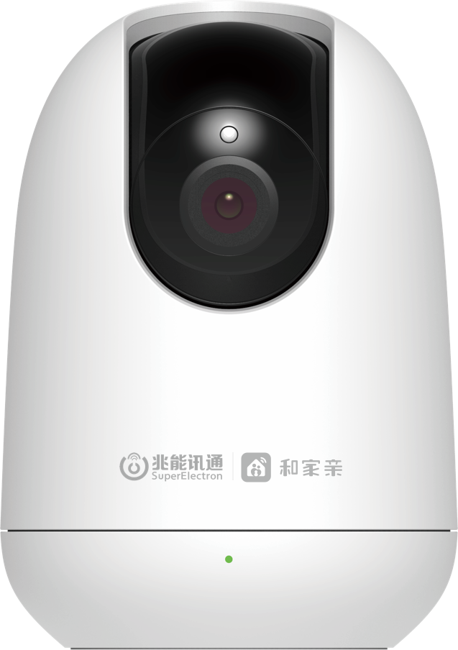
Front | Back

